|  |
| --- |
| **Department of Electrical Engineering** |
| **EE420: Power Electronics** |

|  |  |
| --- | --- |
| **Faculty Member: Dr. Ammar Hassan** | **Dated: 9/14/2022** |
| **Semester: 7th** | **Section: C** |

**Lab01: Uncontrolled Single-Phase Rectifiers**

|  |  |  |  |  |
| --- | --- | --- | --- | --- |
| **Name** | **Reg. no.** | **Report Marks / 10** | **Viva Marks / 5** | **Total/15** |
| **Misbah Saleem** | 304344 |  |  |  |
|  |  |  |  |  |
|  |  |  |  |  |
|  |  |  |  |  |

National University of Sciences & Technology NUST

School of Electrical Engineering and Computer Science SEECS Department of Electrical Engineering

**Introduction**

The IV Characteristics of a diode can be expressed by an equation known as the Schockley diode equation:



The name of a diode must start with D, and it takes the general form

D<name> NA NK DNAME[(area) value]

where NA and NK are the node the cathode nodes, respectively. The current flows from anode node NA through the diode to cathode node NK. DNAME is the model name.

Some diode statements are

D15 33 35 SWITCH 1.5

.MODEL SWITCH D(IS=100E–15 CJO=2PF TT=12NS BV=100 IBV=10E–3)

DCLAMP 0 8 DIN914

.MODEL DIN914 D (IS=100E–15 CJO=2PF TT=12NS BV=100 IBV=10E–3)

The EVAL library of the PSpice student version supports few low power diodes such as D1N4002, D1N4148, and D1N914.



*I*D = current through the diode, A

*V*D = diode voltage with anode positive with respect to cathode, V

*I*s = leakage (or reverse saturation) current, typically in the range 10–6 to 10–20 A *n* = Empirical constant known as the *emission coefficient* (or *ideality factor*), whose value varies from 1 to 2

The emission coefficient, *n*, depends on the material and the physical construction of diodes. For germanium diodes, *n* is considered to be 1. For silicon diodes, the predicted value of *n* is 2, but for most silicon diodes the value of *n* is in the range 1.1 to 1.8.

VT in Equation is a constant called the thermal voltage, and it is given by:

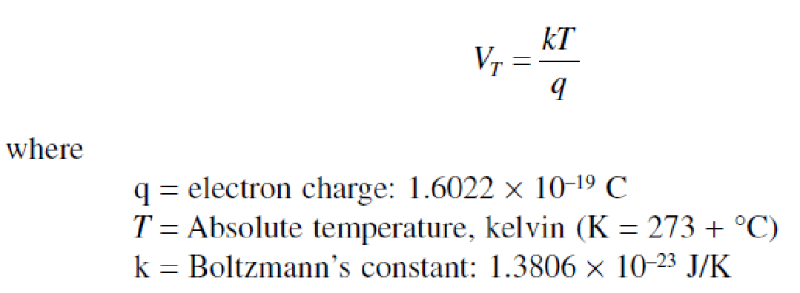

Page **2** of **7**

The equivalent parametrical model of a diode is:



The parameters that are required to model a diode in PSpice are as under:

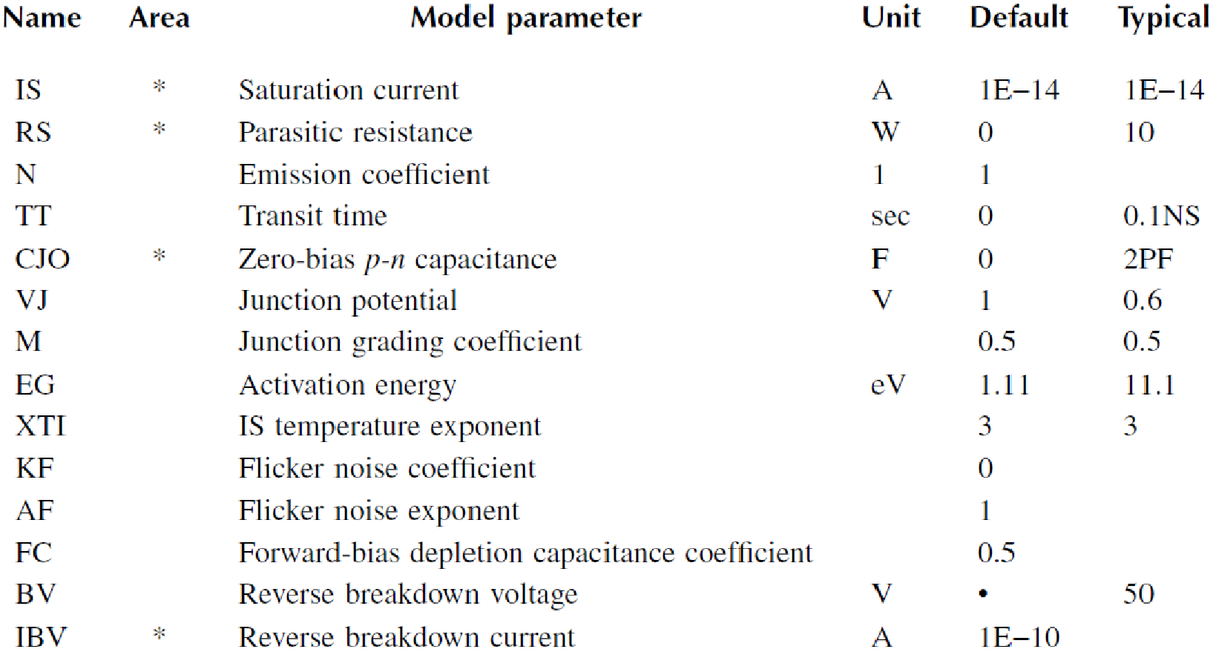

However to keep the modeling simple following statement will give close enough approximation as a diode.

# .MODEL D1N4002 D (IS=2.22E-15 BV=1200V IBV=12E-2 CJO=2PF TT=1US)

**The properties of the diode can be edited by selecting a diode and then going into Edit>PSpice Model.**

National University of Sciences & Technology NUST



School of Electrical Engineering and Computer Science SEECS Department of Electrical Engineering

# Diode Rectifiers

A rectifier converts an AC voltage to a DC voltage and uses diodes as the switching devices. The output voltage of an ideal rectifier should be pure DC and contain no harmonics or ripples. Similarly, the input current should be pure sine wave and contain no harmonics. That is, the total harmonic distortion (THD) of the input current and output voltage should be zero, and the input power factor should be unity.

The output voltage, the output current, and the input current of a rectifier contain harmonics. The input power factor *PF*ican be determined from the *THD*i of the input current as follows:

where

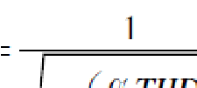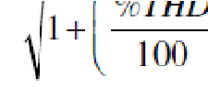

*I*1(rms) = rms value of the fundamental input current *I*s = rms value of the input current

φ1 = angle between the fundamental component of the input current and the fundamental component of the input voltage %*THD* = percentage total harmonic distortion of the input current

## 1. Finding the Performance of a Half Wave Diode Rectifier

A single-phase half-wave rectifier is shown in Figure. The input voltage is sinusoidal with a peak of 169.7 V, 60 Hz. The load inductance L is 6.5 mH, and the load resistance R is 0.5Ω. Use PSpice (a) to plot the instantaneous output voltage vo and the load current io, (b) to calculate the Fourier coefficient of the output voltage, and (c) to find the input power factor. Please use simple diode model and modify PSpice model of D1N4002 as under:

### .MODEL D1N4002 D (IS=2.22E-15 BV=1200V IBV=12E-2 CJO=2PF TT=1US)

FREQ = 60

VAMPL = 17

VOFF = 0

V1

0

D1

D1N4

0

02

0

V

R

1

.

5

I

L1

6.5

m

1

H

2

0

|  |  |  |
| --- | --- | --- |
|  |  |  |
| PSpice simulation setup. (a) Transient setup, (b) Fourier setup. | | |

**Circuit :**

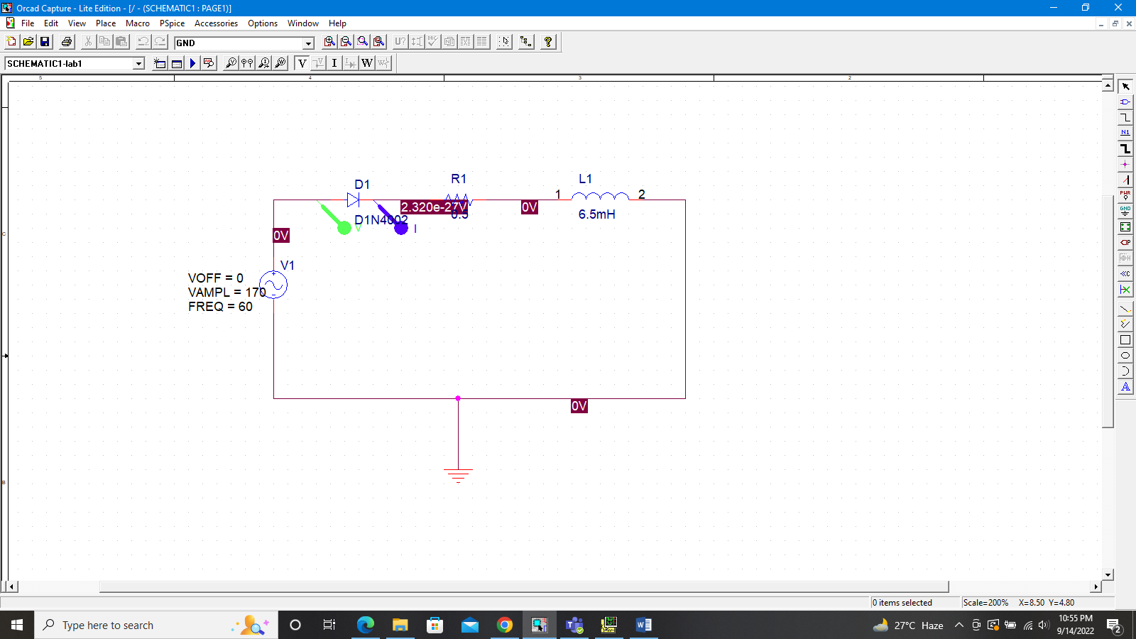

**Output:**

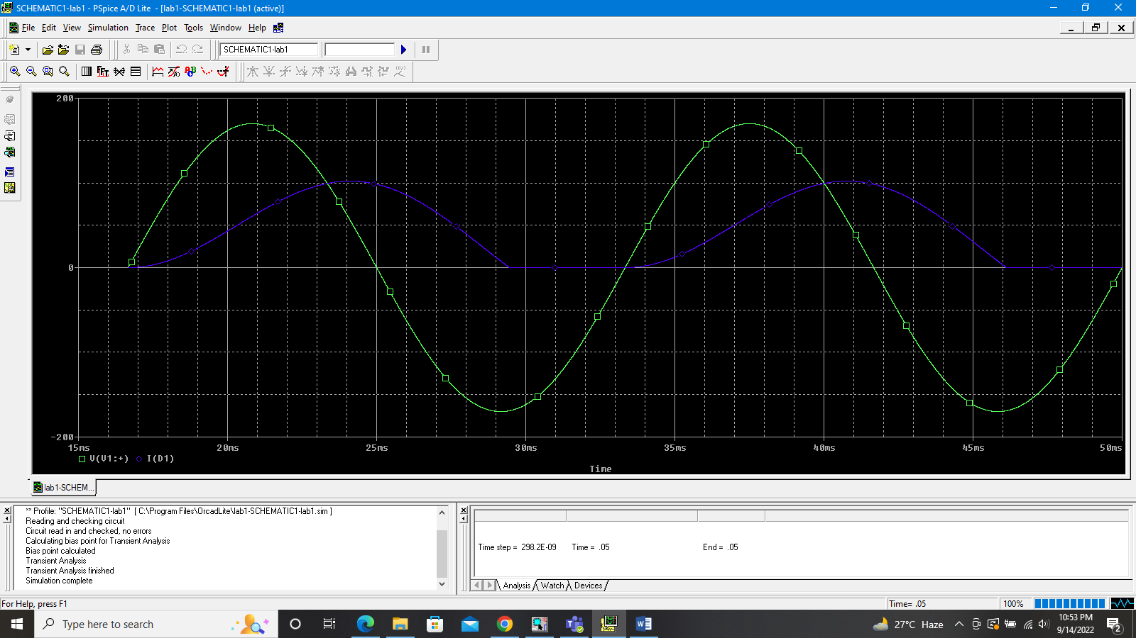

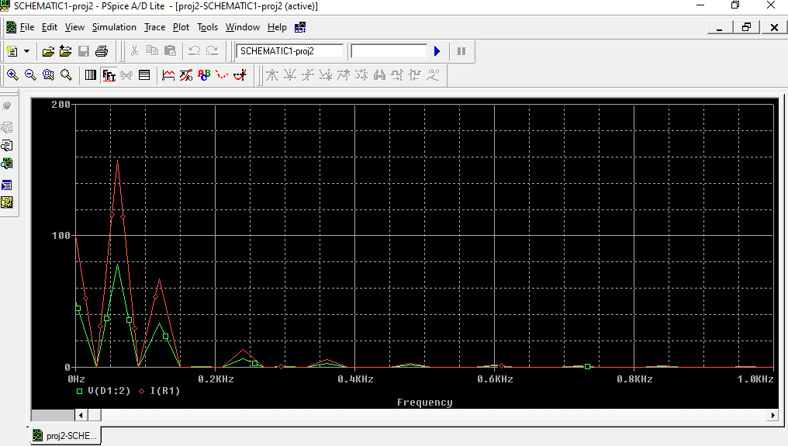

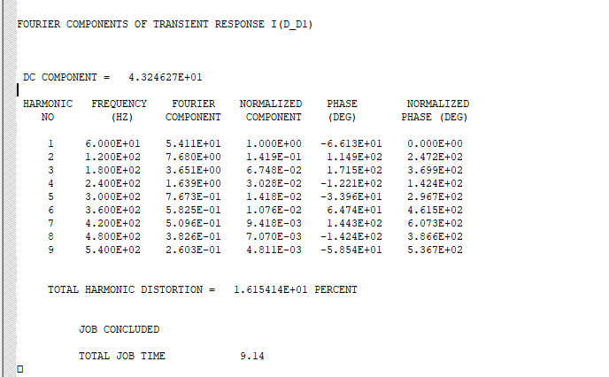

DC input current *I*in(DC) = **43.246**

Rms fundamental input current, *I*1(rms) = **38.26**

THD of input current *THD* = **0.16154**

Harmonic input current, *I*h(rms) = *I*1(rms) ∗ THD = 38.26*0.16154 = **6.1807**

Rms input current, *I*s = [*I2*in(dc) + *I2*1(rms) + *I2*h(rms)]0.5= 2.786

Displacement angle φ1= **66.13**

Displacement factor *DF* = cosφ1= **0.4046**

Thus, the input power factor is given [1] by:

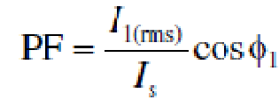 = **0.3994**

The power factor can also be determined directly from the THD as follows:

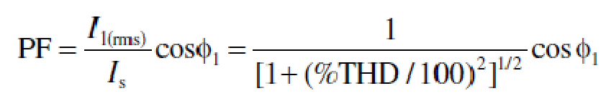

This gives a higher value and cannot be applied if there is a significant amount of DC component.

*Note:* The load current is discontinuous. When the diode turns off, there is a voltage transient. If an antiparallel diode (also known as the freewheeling diode) is connected across the load, the load current will be smoother. As a result, the power factor will improve. Students are encouraged to simulate the circuit with an antiparallel diode to verify this.

## 2. Finding the Performance of a Single­Bridge Rectifier

A single-phase bridge rectifier is shown in Figure. The sinusoidal input voltage has a peak of 170 V, 60 Hz. The load inductance *L* is 6.5mH, and the load resistance *R* is 0.5Ω. Use PSpice (a) to plot the instantaneous output voltage *v*o and the load current *i*o and (b) to calculate the Fourier coefficients of the input current and the input power factor.

D1

D1N4002

V1

FREQ = 60

VAMPL = 170

VOFF = 0

I

D4

D1N4002

D2

D1N4002

V-

R1

0.5

L1

mH

6.5

1

2

0

V2

Vdc

0

D3

D1N4002

V+

|  |  |
| --- | --- |
|  |  |
| PSpice simulation setup. (a) Transient setup, (b) Fourier setup. | |

**Circuit**

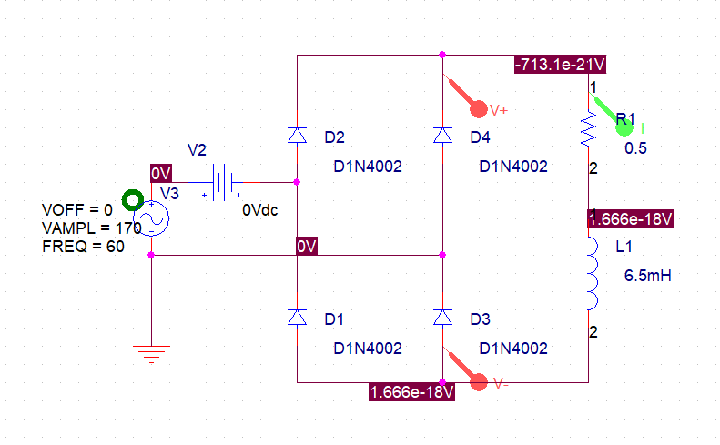

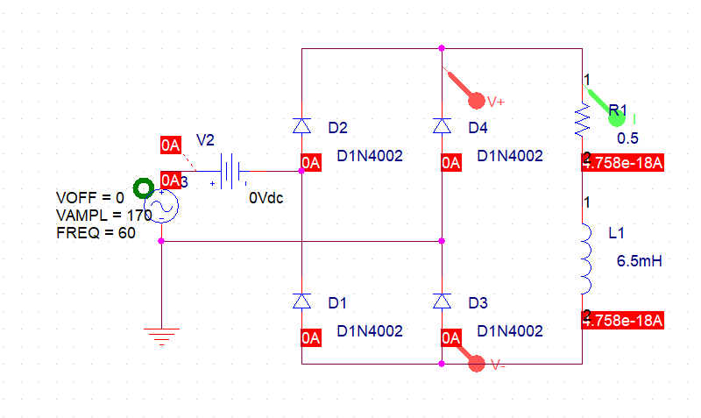

**Output:**

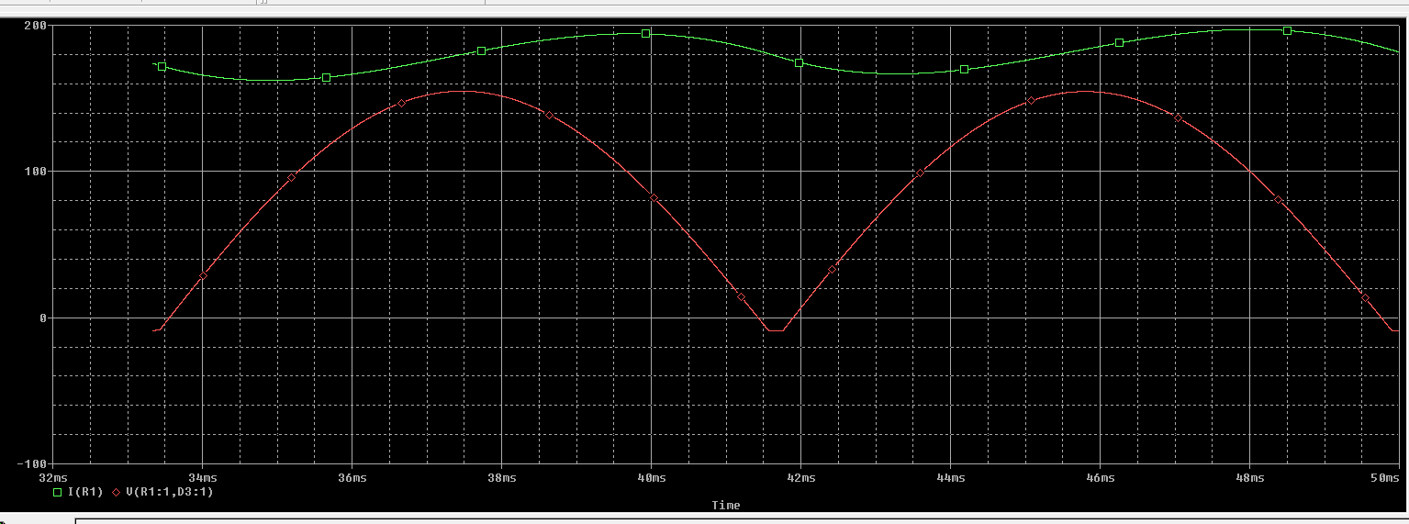 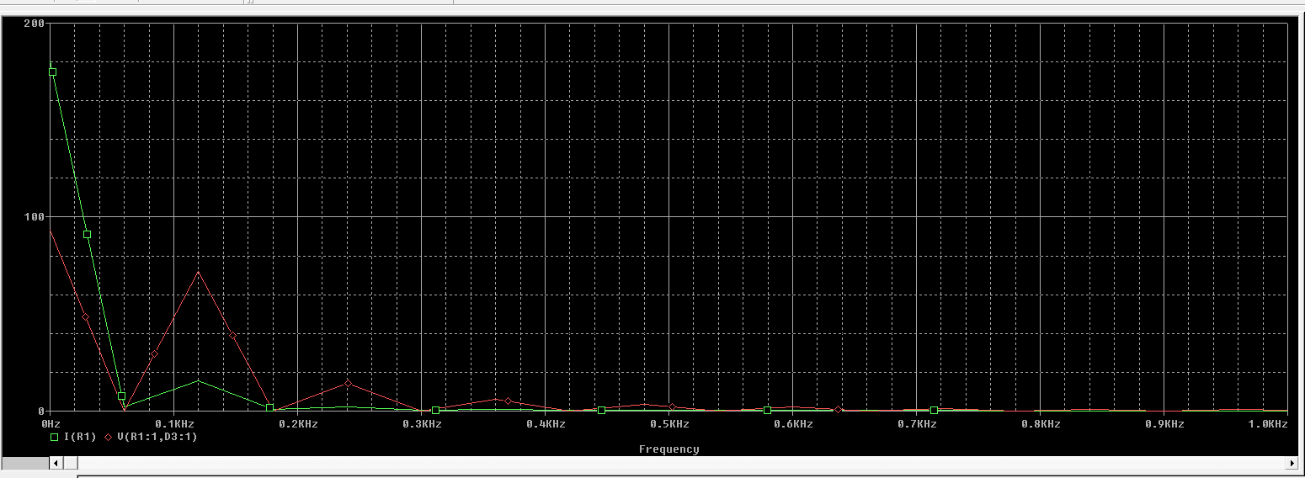

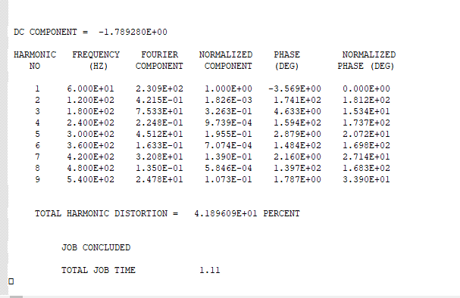

DC input current *I*in(DC) = **-1.789**

Rms fundamental input current, *I*1(rms) = 163.27

THD of input current *THD* = **0.4189**

Harmonic input current, *I*h(rms) = *I*1(rms) ∗ THD = **68.394**

Rms input current *I*s = [*I2*in(dc) + *I2*1(rms) + *I2*h(rms)]0.5= 0.1499

Displacement angle φ1= **3.569**

Displacement factor *DF* = cosφ1**= 0.99806**

Thus, the input power factor is given [1] by:

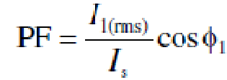 =

The power factor can also be determined directly from the THD as follows:

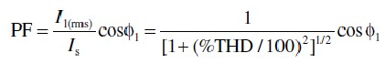 **= 0.9205**

**Conclusion:**

In this Lab, we looked into single phase half wave rectifier. In this first part, as the inductor was also included with the resistor as the load, therefore it becomes the energy source when the negative cycle of applied voltage is at the anode of diode. In the second part, we looked into the bridge configuration. The output voltage is rectified in both cases. For each of the positive and negative voltage cycle, two of the four diodes are closed and therefore current flows through the circuit. The polarity of the current remains same for both cycles.